## **User Interfaces**

The user interface for software should be compatible with iPad Retina, iPhone4, iPod Touch through which the user may access the system. The user interface for this “PartyGuard” application will be implemented using Swift programming in Xcode.

## **Basic User Login Screen**

When the user opens the app for the first time he will be redirected to the login page, where he’ll be given chance to login with Facebook or twitter account. User should provide the Email and Password fields. If the user clicks the login with Facebook button, then he’ll be directed to Facebook authentication page. Similarly, if the user clicks the login with a twitter button he’ll be redirected to twitter authentication page. Once the user successfully logged in, he’ll be redirected to “How to use the App” page.

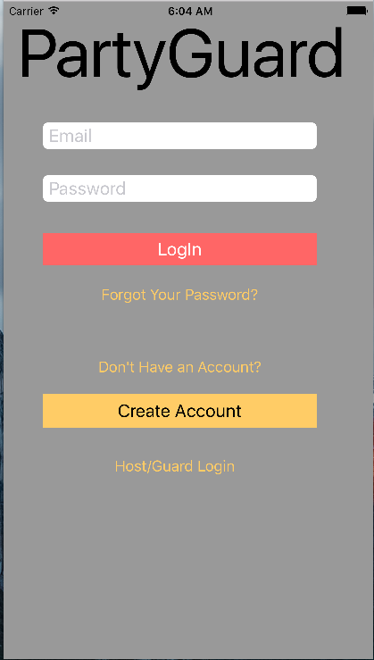

## **Registration Screen**

User will be redirected to registration page he clicks “Create Account” button where user will be given chance to fill the fields that are required for registration. Once the user has created the account then he’ll be redirected to “How to use App” page.

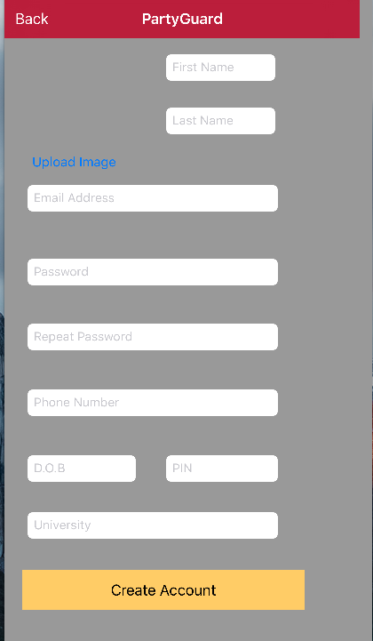

## 

## **How to use App**

The user will be redirected to “How to use App” page when he/she successfully logged in. This page provides the user the information about how to use the app through pictures/videos. Next the user will be redirected the page contains list of fraternities.

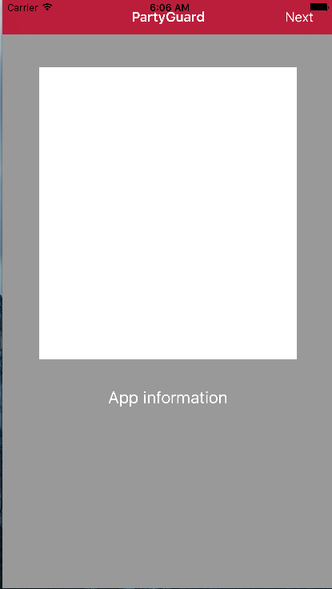

## **Fraternities List**

This page gives the user list of fraternities that are fetched from the database. User will be given a chance to select fraternity to report the issue.

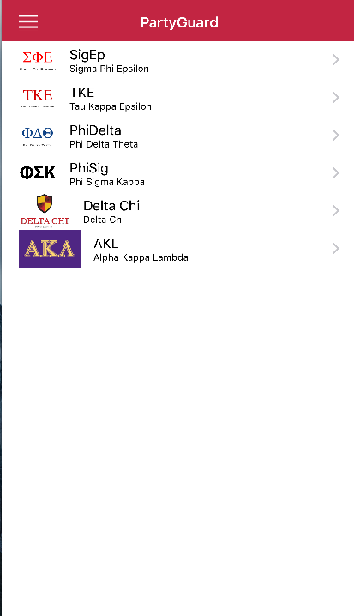

## 

## **Menu**

This page contains the Profile, Location change, Settings, About PartyGuard options along with the Logout option.

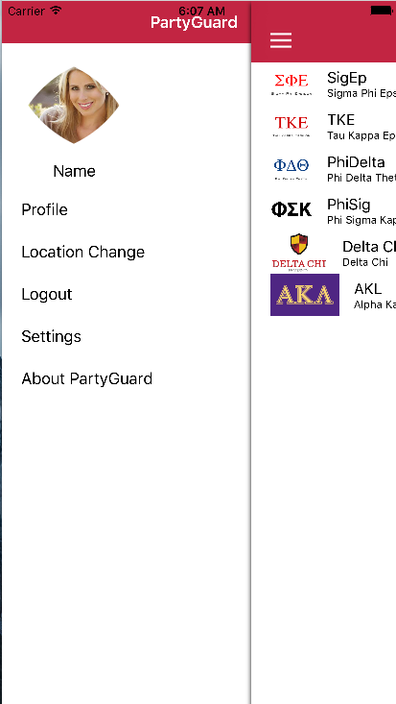

## **Issue Reporting**

This page will allow user to report the issue. User can select from a category of the issue from the list. User can also select emergency button if the issue is not resolved by the fraternity within 15 minutes of reporting.

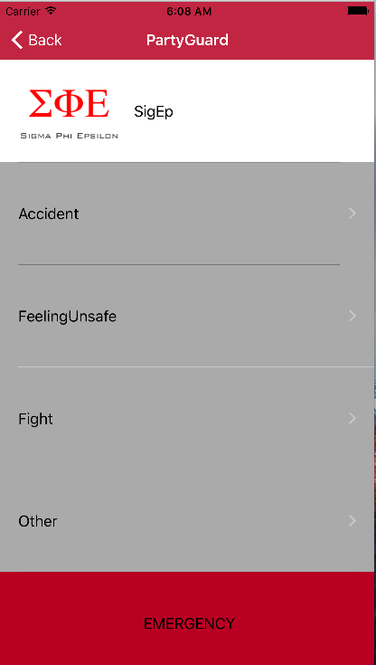

## **User Location**

Once the issue is selected user will get a chance to select his/her location so that fraternity team locate the person reported in that location.

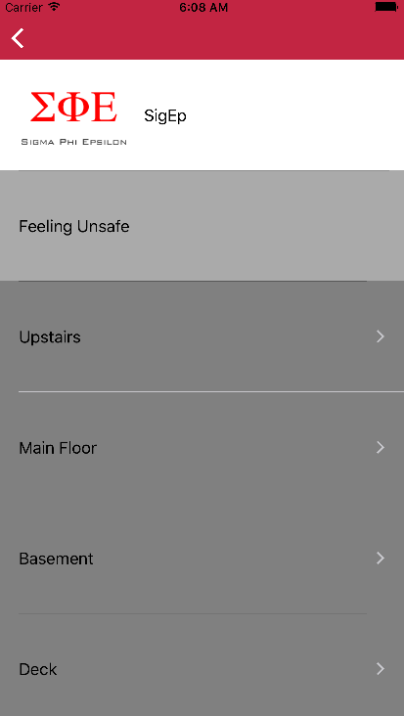

## **Confirmation Page & Assistance Page**

Once the user selects his/her location, he/she will be redirected to page contains the confirmation to report the issue. If the clicks the accept button then pop up will appear “Assistance is on the way”.

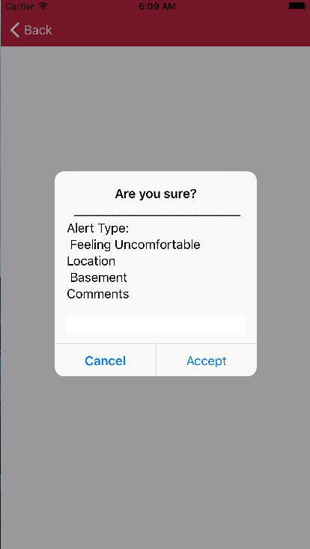

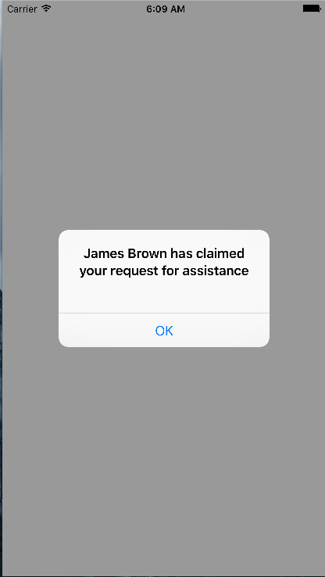

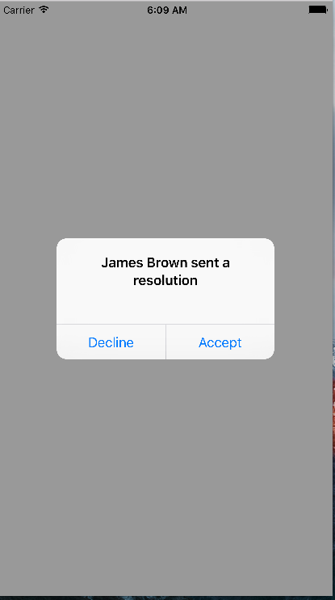

**Host/Guard User Login**

The Host user can navigate directly to this page by clicking on Host/Guard login button from basic user login screen and check the different tabs such as PG team, History, Alerts and Profile.

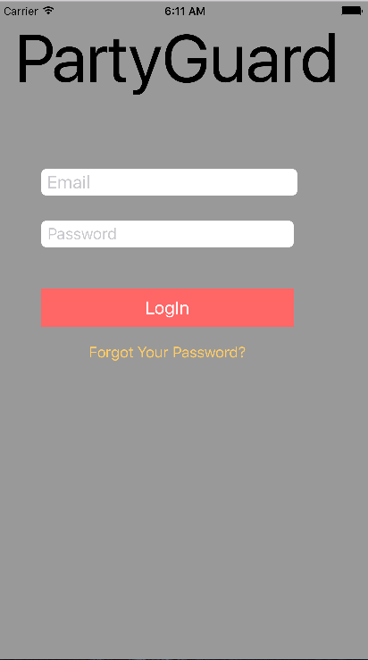

**PG Team tab**

The PG team tab shows the different guards available. The green circle over the guard signifies that currently he was available.

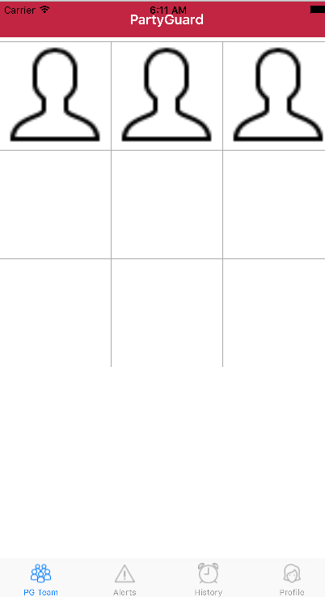

**Alerts tab**

The alerts tab shows the current incidents that need to be resolved by the fraternity head with the help of guard users.

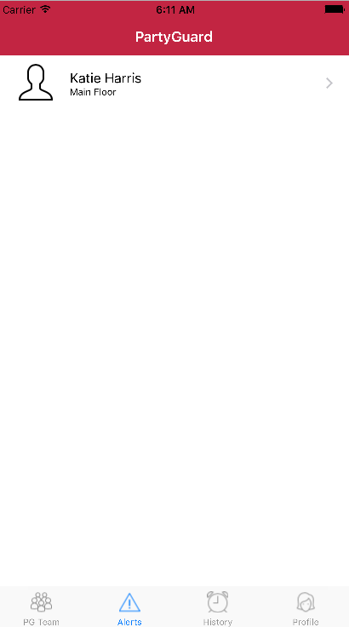

**History tab**

The history tab shows all the previously resolved incidents. It maintains a log for all the resolved incidents so that user can check the incident type and how it been resolved.

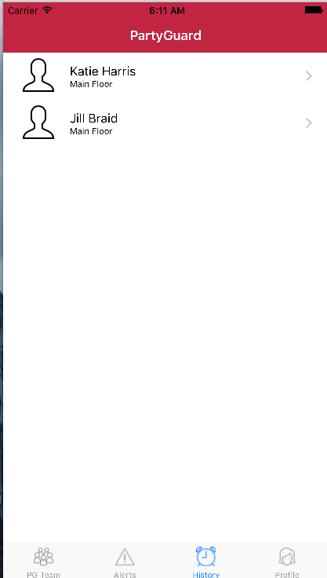

**Profile tab**

The user can alter and manage their profile through this tab. They can change their profile picture, name, location etc.

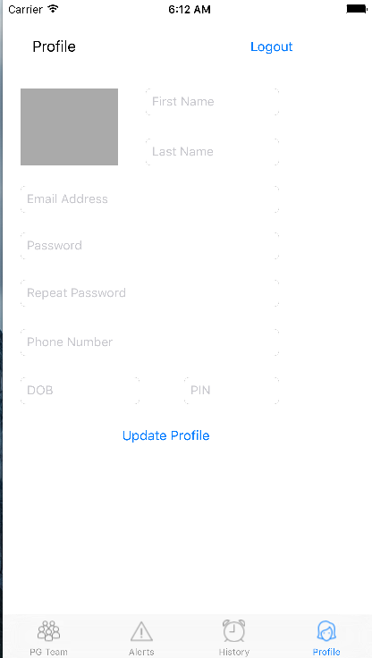

**Forgot password**

The user is provided with forgot password option so that he/she can reset their password through their registered email.

